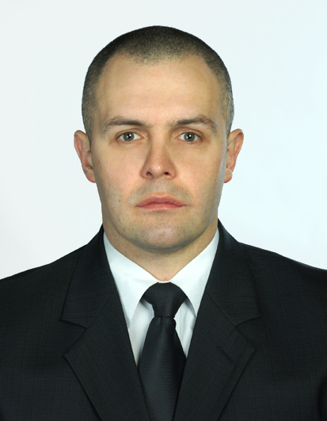
Mykhailo Derba
Address: fl.111, 85 Geroiv Dnipra st., Cherkasy, Ukraine
DOB: 29 January 1981
Email:mykhailoderba@yahoo.com
mihmih81@mail.ru
+9647827323326 +380936059142 +380681706940
Skype: volf1113
Frontline SIA License number 0830018910895136
PERSONAL PFOFILE
A highly motivated and experienced Security Operative of a very adaptable, robust and diligent nature with 16 years of military and Close protection experience. I have the skills and knowledge required to adjust to any situation that may arise, able to control any task given in a calm and mature manner.
KEY SKILLS/AREAS OF EXPERTISE
- Trained and experienced in Close protection.
- FPOS trained.
- MIRA trained.
- Work in PSD team in Iraq.
- Ability to use First Aid skills in work conditions.
- GPS user.
- VHF/HF user.
- Track 24 user.
- Organization and protection of commercial buildings.
- Patrolling and protection of assets in urbanized areas and rugged terrain.
- Ability to act in risk-associated tasks in extreme conditions and hostile environment.
- CCTV operator knowledge.
- Weapon skills: AKM, AK-74, SVD, APS, PM, PB, PKM, AGS-17, RPG-7V, RPG-18; familiarity with ZU-23, Igla, KPVT, M-4, G-36.
- PC proficient .
PROFESSIONAL EXPERIENCE
Feb 2014 – Feb 2015 PSD 2IC/Medic with Blue Hackle, Badra, Iraq
· Deputising for the team leader as required.
· Produced standard operating procedures to be implemented by the PSD 2IC/Medic.
· Conduct trainings of local drivers according to company training program and SOP requirments.
· Analyse daily intelligence information to establish safe routes for operations.
· Ensure the maintenance of the team’s equipment and vehicle serviceability.

Nov 2012 – Sep 2013 – PSD 2IC with Janus Security Iraq, Basra, Iraq
· Deputising for the team leader as required.
· Produced standard operating procedures to be implemented by the PSD 2IC.
· Conduct trainings of local drivers according to company training program and SOP requirments.
· Analyse daily intelligence information to establish safe routes for operations.
· Ensure the maintenance of the team’s equipment and vehicle serviceability.
Jun 2012 –Oct 2012 – PSD team member with Sabre International Security, Badra, Iraq

Protection of high profile clients within Iraq. Safe guarding and protection of all assets and personnel on rig sites, and to and from various locations of work or travel areas.. Route reconnaissance and planning of all tasks for daily tasks. Medical and regular fire and movement training of members to maintain a combat readiness.
Jan 2012 – May 2012 -Maritime Security Team Leader with Sea Gull International Security;
supervise security team of 4 men till transit of trade ships across Aden Gulf.
Dec 2008 – Dec 2011- Close protection officer, Samuray MT, Ukraine
Jun 2008 - Nov 2008 - Security supervisor, Jhitomir, Samuray MT, Ukraine.
Jan 2008 - May 2008 - Close protection officer, Samuray MT, Ukraine.
April 2007 - August 2007 ~ Omega Special Anti-Terror Task Force Officer.
Main tasks:
- Study of standard and specialist methods of shooting with main types of small arms.
- Practical training of standard assault group at storming of urbanized areas, buildings, vehicles, conducting raids on terrorist’s bases, dismounted patrolling tactics.
- Personal protection group
- Learning foreign languages
- Joint operations against armed criminals in urbanized areas, rapid deployment of temporary checkpoint, detention of offenders, policing urbanized areas.
2002 – 2007 ~ Served in patrol Units of the Internal Security Force of Ukraine of Ministry of Inside Affairs of Ukraine.
Roles:
- Patrol Platoon Commander.
- Vehicle Patrol Platoon Commander.
- Deputy Commander of the patrol company on combat training.
- Patrol Company Commander.
Main duties:
- Patrol unit commanding.
- Organization of patrols .
- Personnel military and specialist training.
- Subordinate development and training.
- Preparation of legal documentation as part of my work.
- Undertaken official investigations.
- Organization and execution of non-routine operations such as searching criminals, riots control in town
- Weapons handling training.
EDUCATION
1998 – 2002 Kharkov Military Institute of Internal Security Forces of Ukraine (Ministry of Inside Affairs of Ukraine).
Specialty: Commander of Infantry units
Qualification: Tactical Command Level Officer (Platoon – Battalion) .
2002 – 2005 Donetsk Institute of Law, Ministry of Inside Affairs of Ukraine.
Specialty: Jurisprudence .
Qualification: Lawyer.
Training courses:
May 2014 Medic in Remote Areas course from ExMed ( Horizon Security Solutions)
- Dec 2013 Level 3 Close Protection Course SIA accredited(City & Guilds) Phoenix G4S, Alicante, Spain (Frontline SIA License number 0830018910895136 )
- Nov 2013 First Person on Scene (I) SIA accredited(BTEC), Alicante, Spain.
- Mar 2012 First Aid Course at the Cherkasy Medical Training Center, Cherkasy, Ukraine.
- Feb 2012 Basic Safety Training STCW95 at the Nikolaev Center of Training of Seafarers, Nikolaev, Ukraine.
- Nov 2011 The Use of Small Arms for Security Specialists at the Training Center Grampus, Nikolaev, Ukraine.
- Sep 2011 Ship Security Officer Program at the Maritime Training Center (Odessa, Ukraine).
- Sep 2011 Maritime Security Program at the Guard Security Agency, Alfa-Shield Training Center, Nikolaev, Ukraine.
ADDITIONAL INFORMATION
September 2013 - International Certificate of vaccination against Yellow Fever
Military Rank: Captain of Reserve.
Marital status: Single.
Driving license A, B, C (manual).
Hobbies: Learning foreign languages (English, French), studying small arms and special forces tactics, studying personal protection tactics, kick-boxing and bodybuilding.
Language knowledges:
Ukrainian (Fluent)
Russian (Fluent)
English (Fluent)
French (Basic)

